Suppose you’re designing a toaster. First of all we must turn on the toaster. Heater of the toaster must produce heat in temperature interval (upper and lower temperature limits).

For this purpose, the thermometer measures the temperature of the heater, and when the upper limit of temperature is reached then heater must go into an idle state. This state resists until the heater’s temperature decreases to a lower limit, and then the working state is again aimed. When baked or idle for a period of time, it will enter the shutdown state.

1. **电商购物系统**：在一个电商购物平台中，用户可以浏览商品列表。当用户选择某件商品后，会进入商品详情页。在此页面，用户有多种操作选择：可以点击 “加入购物车” 将商品添加到购物车；也能点击 “立即购买” 直接进入结算流程；还可以选择 “收藏商品”，把商品添加到收藏夹；另外，用户随时能返回商品列表继续浏览其他商品。若在结算时遇到问题，如支付失败，可返回商品详情页重新选择购买方式或返回商品列表。

In an e-commerce shopping platform, users can browse the list of products. When the user selects an item, they will be taken to the product details page. On this page, users have a variety of action options: they can click "Add to shopping cart" to add items to the shopping cart; they can also click "Buy Now" to directly enter the checkout process; they can also select "Favorite Items" to add items to their favorites; in addition, users can return to the product list at any time to continue browsing other items. If you encounter problems during checkout, such as payment failure, you can return to the product details page to re-select the purchase method or return to the product list.

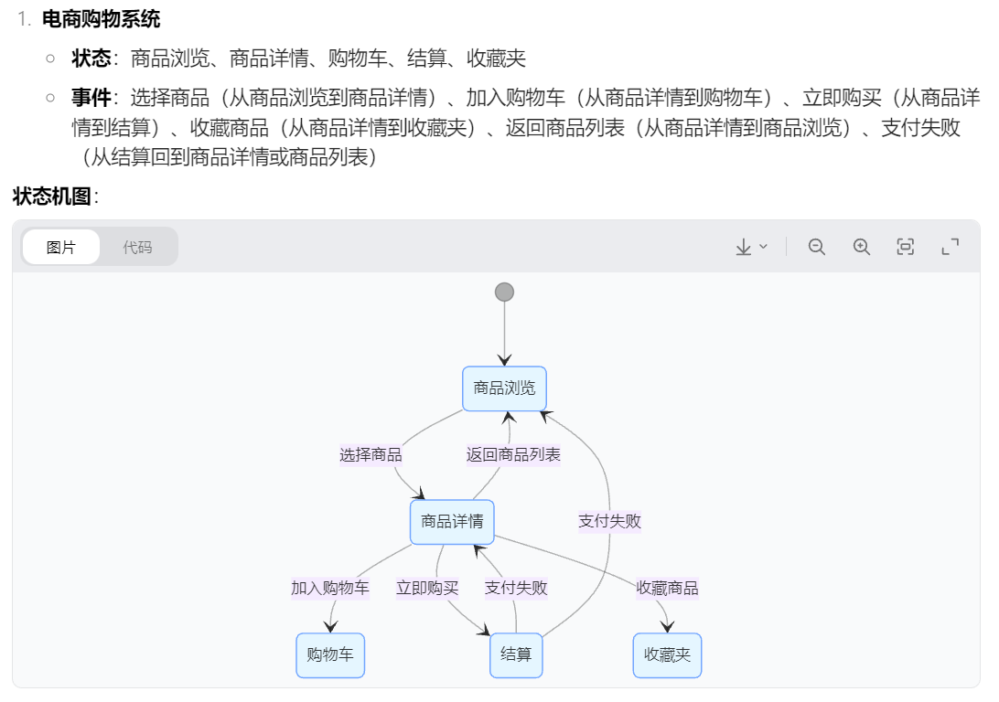

1. **视频播放系统**：在视频播放软件里，用户打开视频后，视频处于暂停状态。此时用户可以选择点击 “播放” 按钮开始播放视频；点击 “暂停” 按钮则让视频暂停；点击 “快进” 按钮可使视频快速前进一定时间；点击 “后退” 按钮能让视频倒退一定时间；还能选择 “关闭视频” 退出播放界面。在播放过程中，如果网络出现问题导致视频卡顿，视频会自动切换到缓冲状态，待网络恢复正常后可继续播放。

In the video playback software, after the user opens the video, the video is in a suspended state. At this time, the user can choose to click the "Play" button to start playing the video; click the "Pause" button to pause the video; click the "Fast Forward" button to make the video move forward quickly for a certain period of time; click the "Back" button to make the video go back for a certain period of time; you can also choose "Close Video" to exit the playback interface. During playback, if there is a problem with the network that causes the video card, the video will automatically switch to the buffering state, and you can continue playing when the network returns to normal.

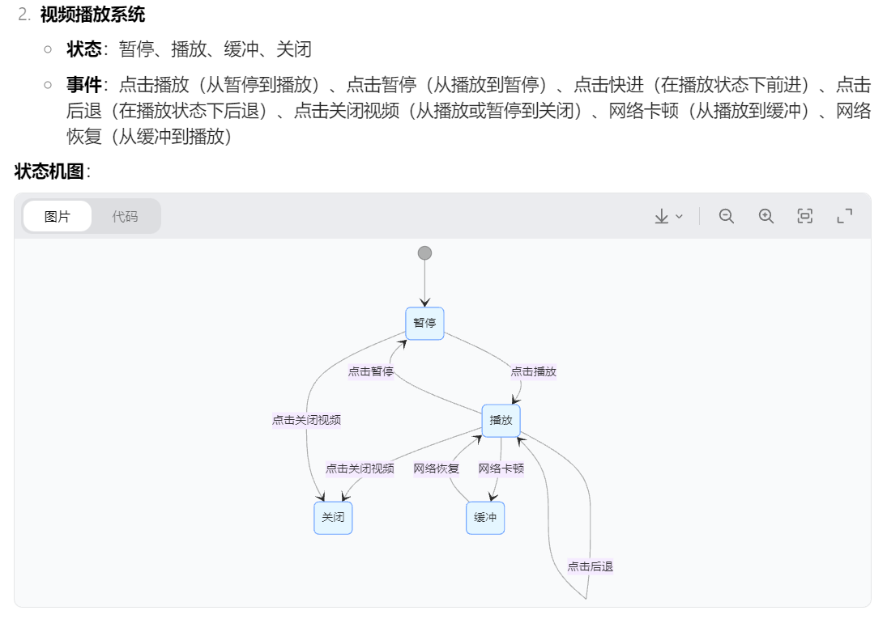

1. **文件管理系统**：在文件管理系统中，用户能看到文件列表。当用户选中某个文件时，会出现多种操作选项：可以点击 “打开文件” 查看文件内容；点击 “重命名” 对文件进行改名；点击 “删除” 将文件移入回收站；点击 “复制” 可复制文件，之后能选择粘贴到其他位置；也能选择 “分享” 文件给其他用户。若在打开文件时，系统提示文件格式不支持，用户可返回文件列表选择其他文件操作。

In the file management system, users can see a list of files. When a user selects a file, a variety of action options appear: you can click "Open File" to view the file content; click "Rename" to rename the file; click "Delete" to move the file into Recycle Bin; click "Copy" to copy the file, and then you can choose to paste it to another location; you can also choose "Share" the file to other users. If when opening the file, the system prompts that the file format is not supported, the user can return to the file list and choose another file operation.

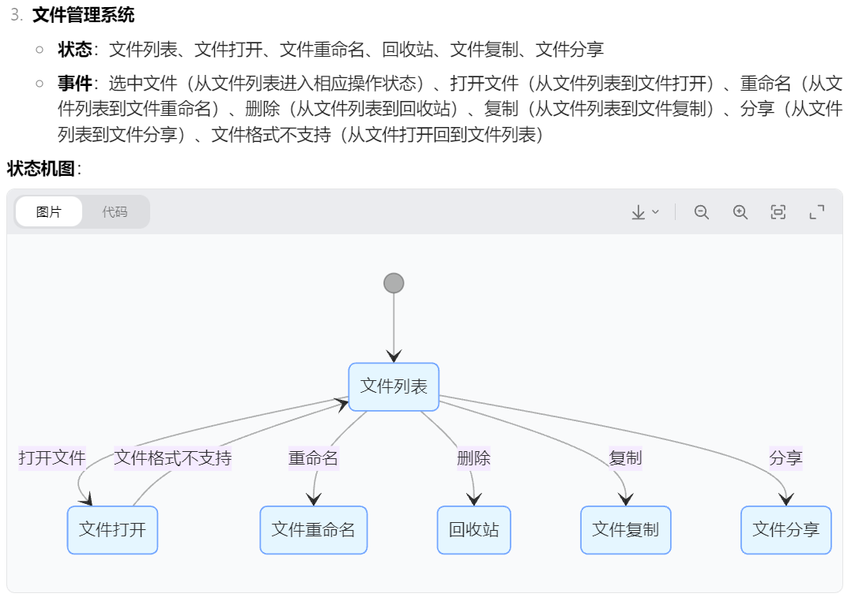

1. **在线学习系统**：在在线学习平台，用户登录后进入课程列表页面。用户可以选择点击 “进入课程” 开始学习某门课程；点击 “收藏课程” 将课程添加到收藏；点击 “课程评价” 对已学课程进行评价；点击 “退出登录” 离开平台。在学习课程过程中，用户可点击 “暂停学习” 暂停课程，之后点击 “继续学习” 可回到暂停处继续；若遇到不懂的内容，还能点击 “标记难点”，方便后续复习。

On the online learning platform, users log in to enter the course list page. Users can choose to click "Enter Course" to start learning a certain course; click "Favorite Course" to add the course to their collection; click "Course Evaluation" to evaluate the course they have learned; click "Logout" to leave the platform. During the course learning process, users can click "Pause Learning" to pause the course, and then click "Continue Learning" to return to the pause to continue; if they encounter content they do not understand, they can also click "Mark Difficulties" to facilitate subsequent review.

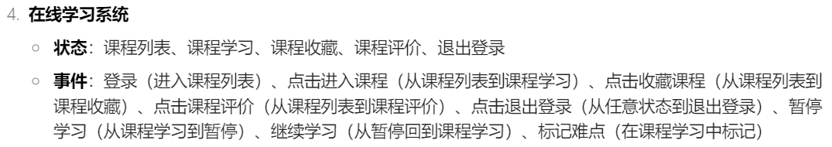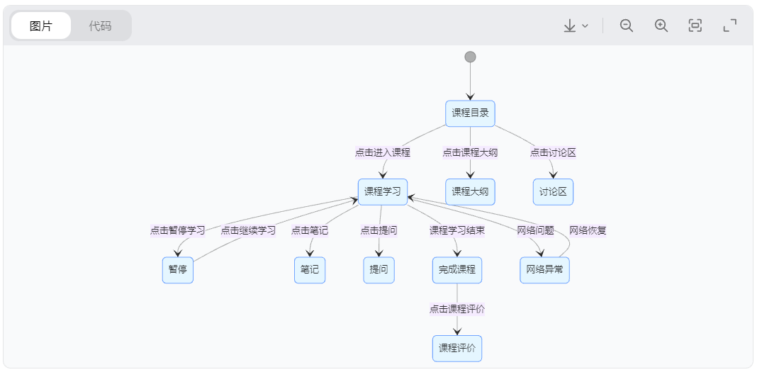

1. **餐厅点餐系统**：在餐厅的点餐系统中，顾客打开菜单后，可浏览菜品列表。顾客可以选择 “添加菜品” 将心仪菜品加入点餐清单；点击 “删除菜品” 从点餐清单中移除已选菜品；点击 “确认点餐” 提交订单；点击 “清空清单” 清除点餐清单重新选择；也能点击 “查看推荐” 获取餐厅推荐菜品。若在确认点餐时发现金额超出预算，可返回菜单重新调整点餐清单。

In the restaurant's ordering system, customers can browse the list of dishes after opening the menu. Customers can choose "Add Dishes" to add their favorite dishes to the ordering list; click "Delete Dishes" to remove the selected dishes from the ordering list; click "Confirm Order" to submit the order; click "Clear List" to clear the ordering list and re-select; or click "View Recommendations" to get the restaurant's recommended dishes. If the amount is found to exceed the budget when confirming the order, you can return to the menu to readjust the ordering list.

